 Art Document

Document Issue: 1.0 Document Status: In Progress
Date Issued: March 22,2002 Filing Path:
Document Title: Prop Library and Layout
                - Author: Jeffrey Pidsadny

Revision History
Issue | Date | Person | Reason - include problem #, ECN #, etc.
1.0 | March 22, 2002 | Jeffrey P | Initial draft of document

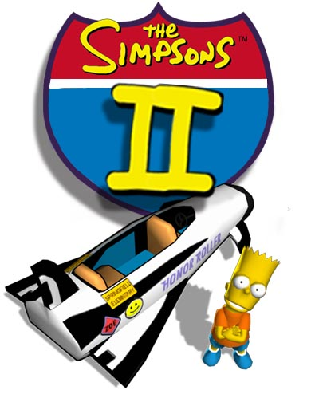

DOCUMENT SUMMARY

DESCRIPTION

This art asset management document is intended to provide detailed information on the prop construction, library, layout and iteration process to be utilized.

This document will be updated when necessary as we continue to refine our technology, game and art design.

OVERVIEW

An important part of Level Construction is building and management of props. Without the proper ability to construct, organize, layout and iterate props and their location it will greatly impede on the Level Building process.

DISCUSSION

This document follows a round table meeting (March 22, 2002) that include the following team members

Simpsons
Jeffrey Pidsadny ,Artist
Vincent Chin , Artist
Trevor Lim, Artist
Kevin Fink, Artist
Cary Brisbois, Programmer
Greg Mayer , Programmer

Pure3d
Kevin Voon
Bryan Ewert

Squidney
Ivan Mickovic, Artist
Mike Anderson, Programmer

Mirth
Wallace Robinson, Artist
Tom Legal, Programmer
Tim Bennison, Programmer
Scott Anderson, Programmer
Hulk
Steve Mele, Artist
Jake Pokorny, Artist
Terry Barton, Designer/ Artist
Jeremy Isaak, Programmer
Dark Angel

OVERVIEW

The purpose of the discussion was to outline a series of categories or goals that the Prop placement process should include. Existing team processes and tools were brought forth and discussed in relation to their pros and cons. An early proposal for Simpsons 2 was put forth and discussed. Further discussion towards a more global solution was proposed.

OUTLINE

Simpsons 2 – Prop Layout and Iteration Process

The purpose of Friday’s meeting is for our team to discuss the process that we will be implementing towards props layout and iteration, the current tools/techniques being used at Radical and the possibility for developing new tools or augmenting existing tools that may assist future teams (ie, the good people over in Hairclub as well as ourselves). We would like to limit the discussion to focus on the laying out of multiple common props in a scene and the process of iterating them. (meta-data and attributes unique to these props, (ie smartprops) is not a focus at this time).

Our team has developed a pretty straightforward meeting pattern that involves 3 steps for discussion that we would like to implement….

- GOALS – what criteria could evaluate your process
- PRO/CON – evaluate your existing process using these goals
- BRAINSTORM – steps for future tool

To make the meeting quick and to the point we would like to propose the following GOAL questions for your consideration and evaluation (PRO/CON) prior to the meeting….

- Is your procedure tool Maya based?
- Does the procedure involve offline tools, scripts, command line process etc?
- Is the tool a run-time application?
- Does the procedure involve a prop library?
- Co-ordination – How easy is it to co-ordinate props (library) with the naming
conventions, external database, directory structure etc….
- Is there a prop validation process? (name, size, textures, naming etc…)
- Is the prop represented at high resolution (what the prop accurately looks like)?
- Is the prop represented in a low-resolution version (for Maya speed)
- How easy is it to iterate the props or the high res Rep.
- How easy is it to iterate the props low res. Rep?
- How easy is it to iterate the props duplicate/instance transform/location/rotation?
- How well does the procedure implement the .p3d and the exporter?
- Does the procedure involve additional exporters? Evaluate.
- Other

BRAINSTORMING

Results of the meeting include the following discussions and proposals…

Jeff Pidsadny – Maya’s abilty to reference and instance and update props should not be used in the Level Building process. Both internally and externally this functionality in Maya has been proven to be flawed.

Mike Anderson – Squidney’s current prop system work be using a library of props that replace an exported scene file that lays out properly named representations of the prop. In the pipeline the scene props are stripped of everything but transformation and rotation. This information is passed along to the library file where correctly named props are replaced. The process requires proper naming and a managed database, involves a manual process for replacing or iterating on the Maya workflow object. This solutions simplicity was favored over it’s iteration process. If a custom tool is to be developed in the future, attributes and state changes must be included to reduce future headache.

Bryan Ewert – A custom representation script was implemented at H20 that used “dependency nodes” that referenced their proprietary exported meshes (.iff files) – outside of the Maya’s referencing and instancing. The same process could be implemented at Radical using .p3d files.

Jeremy Isaak – Stated everyone’s belief that Maya is not a world building tool, but an art creation tool, good at polygon modelling and texturing. If prop-placement and world building is to be globally investigated time and effort should be spent on developing a run-time the incorporated prop placement, attribute modifying and state changes. All parties agreed.

Wallace Robinson – Proposed a tool that references .p3d files and uses locators or vertex points on a curve to locate the props. An offline viewing tool would be required to view the p3d files correctly. Ensuring that props retain relationship to the ground and other attributes was discussed.

Greg Mayer – A new node should be incorporated into the p3d exporter to handle instanced groups. The current use of a skeleton route on the grouped instances treats all instances as a composite drawable and is not idea in the game engine. Kevin Voon is investigating.

GLOBAL GOALS
The following global goals for prop placement and world building were proposed.

Any further investigation towards a global world-building tool should incorporate …

- Proper use of a library of props, referencing and instancing capabilities.
- Attribute and state change manipulation
- A runtime environment interface for dynamic props
- A Maya environment interface for static props
- General functionality that may be enhanced by individual teams

TEAM GOALS

The following Team goals exist towards Props Construction and Layout

- The process should be Maya based
- Excluding the pipeline, no other offline tools should be required.
- The process will not exist in runtime
- The process will involve a Prop Library
- A prop Library database will be constructed and maintained
- A prop validation process we be used to check exported art using the Prop database
- The props should be able to be represented at high resolution
- The props should be able to be represented at low resolution
- All props will exist in their own unique file for easy iteration. All meshes will be created at the origin with the pivot at the lower left hand corner. The pivot point will be the insertion point for all props.
- ?? How will low res. models be incorporated??
- Prop layout and location will be done with source and instance ability. The instances will be grouped and a new root node will be used on the group. Naming of the Original shape to co-ordinate with the library file is essential.
- Props will be exported with the P3D exporter into unique Library directory. The layout of the props will be exported into a Level Props Layout P3D file. The pipeline will manage replacing the Prop Layout information with the Library Prop.
- No other exporter should be used

Proposal A – Pipeline Replacement (name dependant)

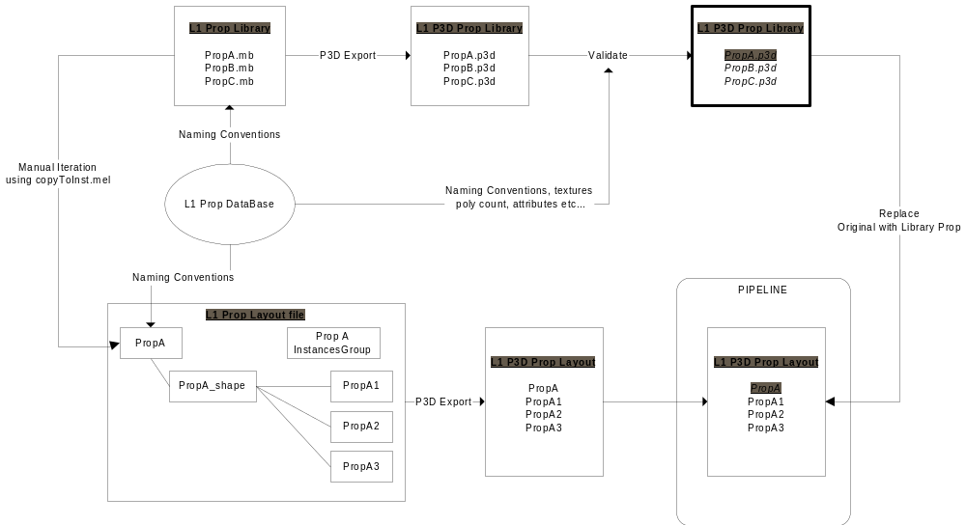

Proposal A – Reference Node
